THE TITLE GOES HERE WITH ALL LETTERS CAPITALIZED, FRANKLIN GOTHIC DEMI FONT, 13 PT
First Author’s Name^{1,}*, Second Author’s Name², Franklin Gothic Demi Font, 12 pt
¹First Author's Affiliation, Address, Country
²Second Author's Affiliation, Address, Country
*corresponding author: e-mail
The paper should be written in MS Word in English according to the specified formatting styles. The main text is formatted as TEXT style. The paper may contain a maximum of 2 A4 pages, including figures, tables and references.
Symbols of variables in formulas and in the text should be written in italics, whereas vectors and matrices in bold. Formulas should be written using the MS equation editor and placed according to the defined tabulators (FORMULA style):
$E=mc^{2}$ (1)
Figures with a resolution of at least 300 DPI should be inserted in line with text and formatted in FIGURE style. Colorful figures are accepted. Graphic objects cannot be linked with the source program. Figure caption style is defined as FIG_CAPTION.
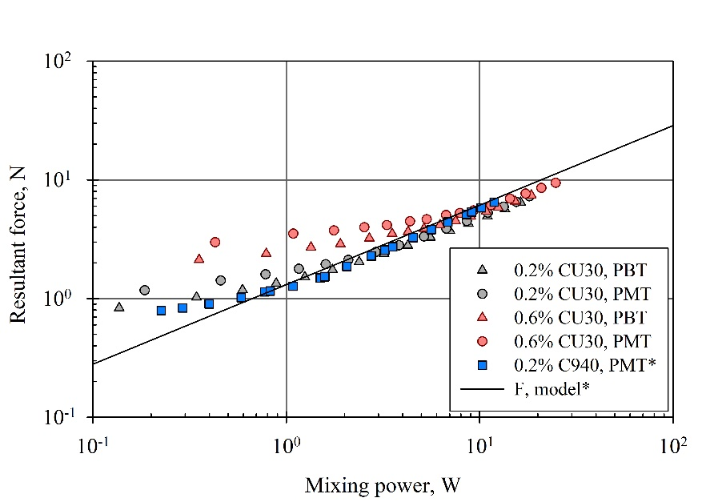
Fig. 1. Caption of Figure 1
Tables are centered with the title above. The table content is formatted as TABLE_TEXT and the title style is defined as TABLE_CAPTION.
Table 1. Caption of Table 1
Column 1 | Column 2 | Column 3 | Column 4
Row 1
Row 2
Row 3

Reference number cited in the text is given in square brackets, e.g. [1]. The reference list is formatted in REFERENCE_ITEM style.
References
- Bridgman P.W., Dimensional Analysis, New York, AMS Press 1978.
- Zeilinger A., A foundational principle for quantum mechanics, Found. Phys., 1999, 29(4), 631-643.
- Pakowski Z., Mujumdar A.S. (2006). Basic process calculations and simulations in drying, in: Handbook of industrial drying, Mujumdar A.S. (Ed.), Boca Raton, CRC Press 2006, 51-76.
- …

